Zhejiang University -CRL Joint Project Report

Basic Information
Project Title: Social Enabled Semantic Data Mashup
2008 UR Theme: WATP

IBM CRL Contact: Gou Tong Xie
Contact Phone: 010-58748425
E-mail: xieguot@cn.ibm.com

University / Department: College of Computer Science, Zhejiang University
Professor: Huajun Chen
Contact Person: Huajun Chen
Contact Phone: 13958093536
E-mail: huajunsir@gmail.com

Proposed Start Date: Proposed End Date:

Actual Start Date: Actual End Date:

Project Summary
- Research Project Describe
The Joint Project Research focuses on providing a novel data mashup framework based upon semantic Web technologies, social community and collective intelligence to mine the relationships between data APIs for facilitating various users to build mashups easily and intuitively.
Research Team Introduction
This Joint Project is carried out by Zhejiang University and IBM CRL cooperatively. This research team is composed of 1 supervisor and 5 students, which is led by Professor Huajun Chen.

Research content
Discovery of Relationships/Links between Data APIs.
Proliferation available data APIs give rise to phenomenal growth of mashup applications on the Web. However, what accompanies with this are the problems that users encounter during mashup building, including (1) the difficulties to locate and combine the right data APIs because of lack of knowledge about these APIs and relationships amongst them; (2) inconvenient and unpleasant steps to be performed whenever they want to mashup a new API, such as finding and reading its specification, deciphering the appropriate functions to be used, checking its mashupability with other APIs, etc; (3) limited ability to discover more mashupable APIs which may make their mashups more abundant.
In order to resolve above three issues, we are studying how to discover the relationships between data APIs for constructing and visualizing a data API network to inspire users and enable the building of interesting mashups.
Semantic-based Automatic Mashup Composition.
One big challenge for current mashup applications is how to make mashup manipulation automatic and intelligent as far as possible. We are going to study in depth on how semantic technology can facilitate in automatic mashup annotation, discovery, recommendation, and composition.

- The activities involved in this project
A conference is hold every week for reporting the progress, discussing the problems, etc. A Workshop will be hold in 5/2009.
- Major Result
The key results of this project are:
- Two or three papers in PIC top quality conferences, such as WWW, VLDB and ISWC;
- A novel mashup system
Research value
The key innovation and technical value underlying this project are the discovery of relationships/links between Data APIs for constructing and visualizing a data API network and semantic-based mashup composition.
Joint Papers
Through the effective communication and cooperation, we have obtained great achievement in research:

Authors | Title | Status
Bin Lu, Zhaohui Wu, Yuan Ni, Guotong Xie, Chunying Zhou, Huajun Chen | sMash: Semantic_based Mashup Navigation System for Data API network, In Proceedings of the 18th World Wide Web Conference (WWW2009), Madrid, Spain, April 2009 | Accept
Bin Lu, Huajun Chen, Yuan Ni, Guotong Xie, Chunying Zhou | Mashup by Surfing a Web of Data APIs, the 35th VLDB conference (VLDB 2009) | Submit
Bin Lu, Huajun Chen, Yuan Ni, Guotong Xie | Semantic mashup based on a Web of Data APIs (Sigmod 2010) | In preparation
Prototype/delivered software/implement
We developed a novel Web data mashup system, sMash – short for semantic-based Mashup, by leveraging the power of semantic, social community and collective intelligence technologies. The current version of sMash is accessible at http://www.dart.zju.edu.cn/mashup. Compared with current industrial mashup tools, including IBM Mashup Center, Yahoo Pipes, Microsoft Popfly and Intel Mash Maker, it offers the following four unique features which cover several mashup scenarios that cannot be addressed well by them:
- Feature 1: Automatic Generation of Mashup Graph.
This can be applied to users who have clear ideas about which data APIs to use and how the mashup results should be like. By using current mashup tools, to construct a mashup graph, users need to use drag-and-drop tools to select APIs or specify URL of APIs; choose the appropriate functions; then connect them one by one. By using sMash, what users need to do is a little bit “fuzzy-match-keyword-search” for the name of APIs; then a mashup graph is generated automatically.
- Feature 2: Surf and Mashup.
This is convenient for users who have no clear purpose of their mashup results. All of the current mashup tools cannot address this scenario. In sMash, each API can be regarded as a Web page. By an interactive interface, users can surf the data API network just like surfing the Web and mashup their interested APIs by leaving a trace. sMash is clever enough to record all the traces to form a mashup graph and tell users this is the mashup they want to build.
- Feature 3: Trace-based Recommendation.
Users, especially novice end-users, may still feel confused during surfing since they have to face such a large size of APIs. sMash can quickly grasp users’ intention by analyzing the traces they have kept up to now, and provide a real-time recommendation about top-10 most popular links to go next.
- Feature 4: Inference-based Recommendation.
This is a more interesting feature which may attract power users. sMash exploits and visualizes the undiscovered APIs and links, and recommends top-10 links based on users’ traces to encourage interested users to surf and mashup which may bring them amazing results.
Figure 1 shows the architecture of sMash. It consists of two main components: user interface and sMash Server. Layered approach is adopted in the design of server, which ensures the flexibility and scalability of the system.
Figure 2 shows an overview of sMash. We take advantage of the descriptiveness of RDF model to incorporate rich semantics of metadata (schema) of API, including tags, category and data content. Furthermore, microformats-like frequently used semantic data types, such as “geo”, “photo” and “event”, are defined in order to describe data content precisely. API schema editor and data type editor are developed to enable users, especially developers, to contribute the schemas of data APIs as well as semantic data types to ensure the scalability of the data API network.
The screenshot in Figure 3 shows a typical mashup scenario when a tourist wishing to build a mashup about beach is surfing the partial visualized network. After navigating to some APIs near “Flickr” and browsing the detailed information, she/he masters these APIs as well as the relationships amongst them quickly and comes up with a good mashup idea which is finding events, the latest posts about beach from “Upcoming”, “Twitter” and “GoogleSearch”, then taking the title of each result as input to search for related photos from “Flickr” and finally displaying these photos on “GoogleMap”. With the help of friendly interactivity of the network, this idea is quickly realized. Next, by enabling the trace-based recommendation functionality, she/he receives a list of most related links which may bring her/him more inspiration. Taking “YoutubeGoogleMap” for example, it can make her/his final mashup result integrate not only the photos about beach but also the related videos. Gradually, by means of surfing and recommendation, her/his mashup becomes more and more abundant.
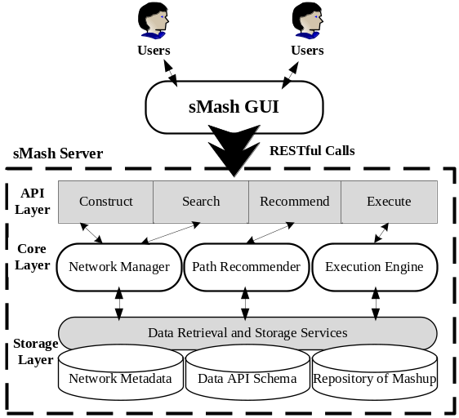
Figure 1: Architecture of sMash
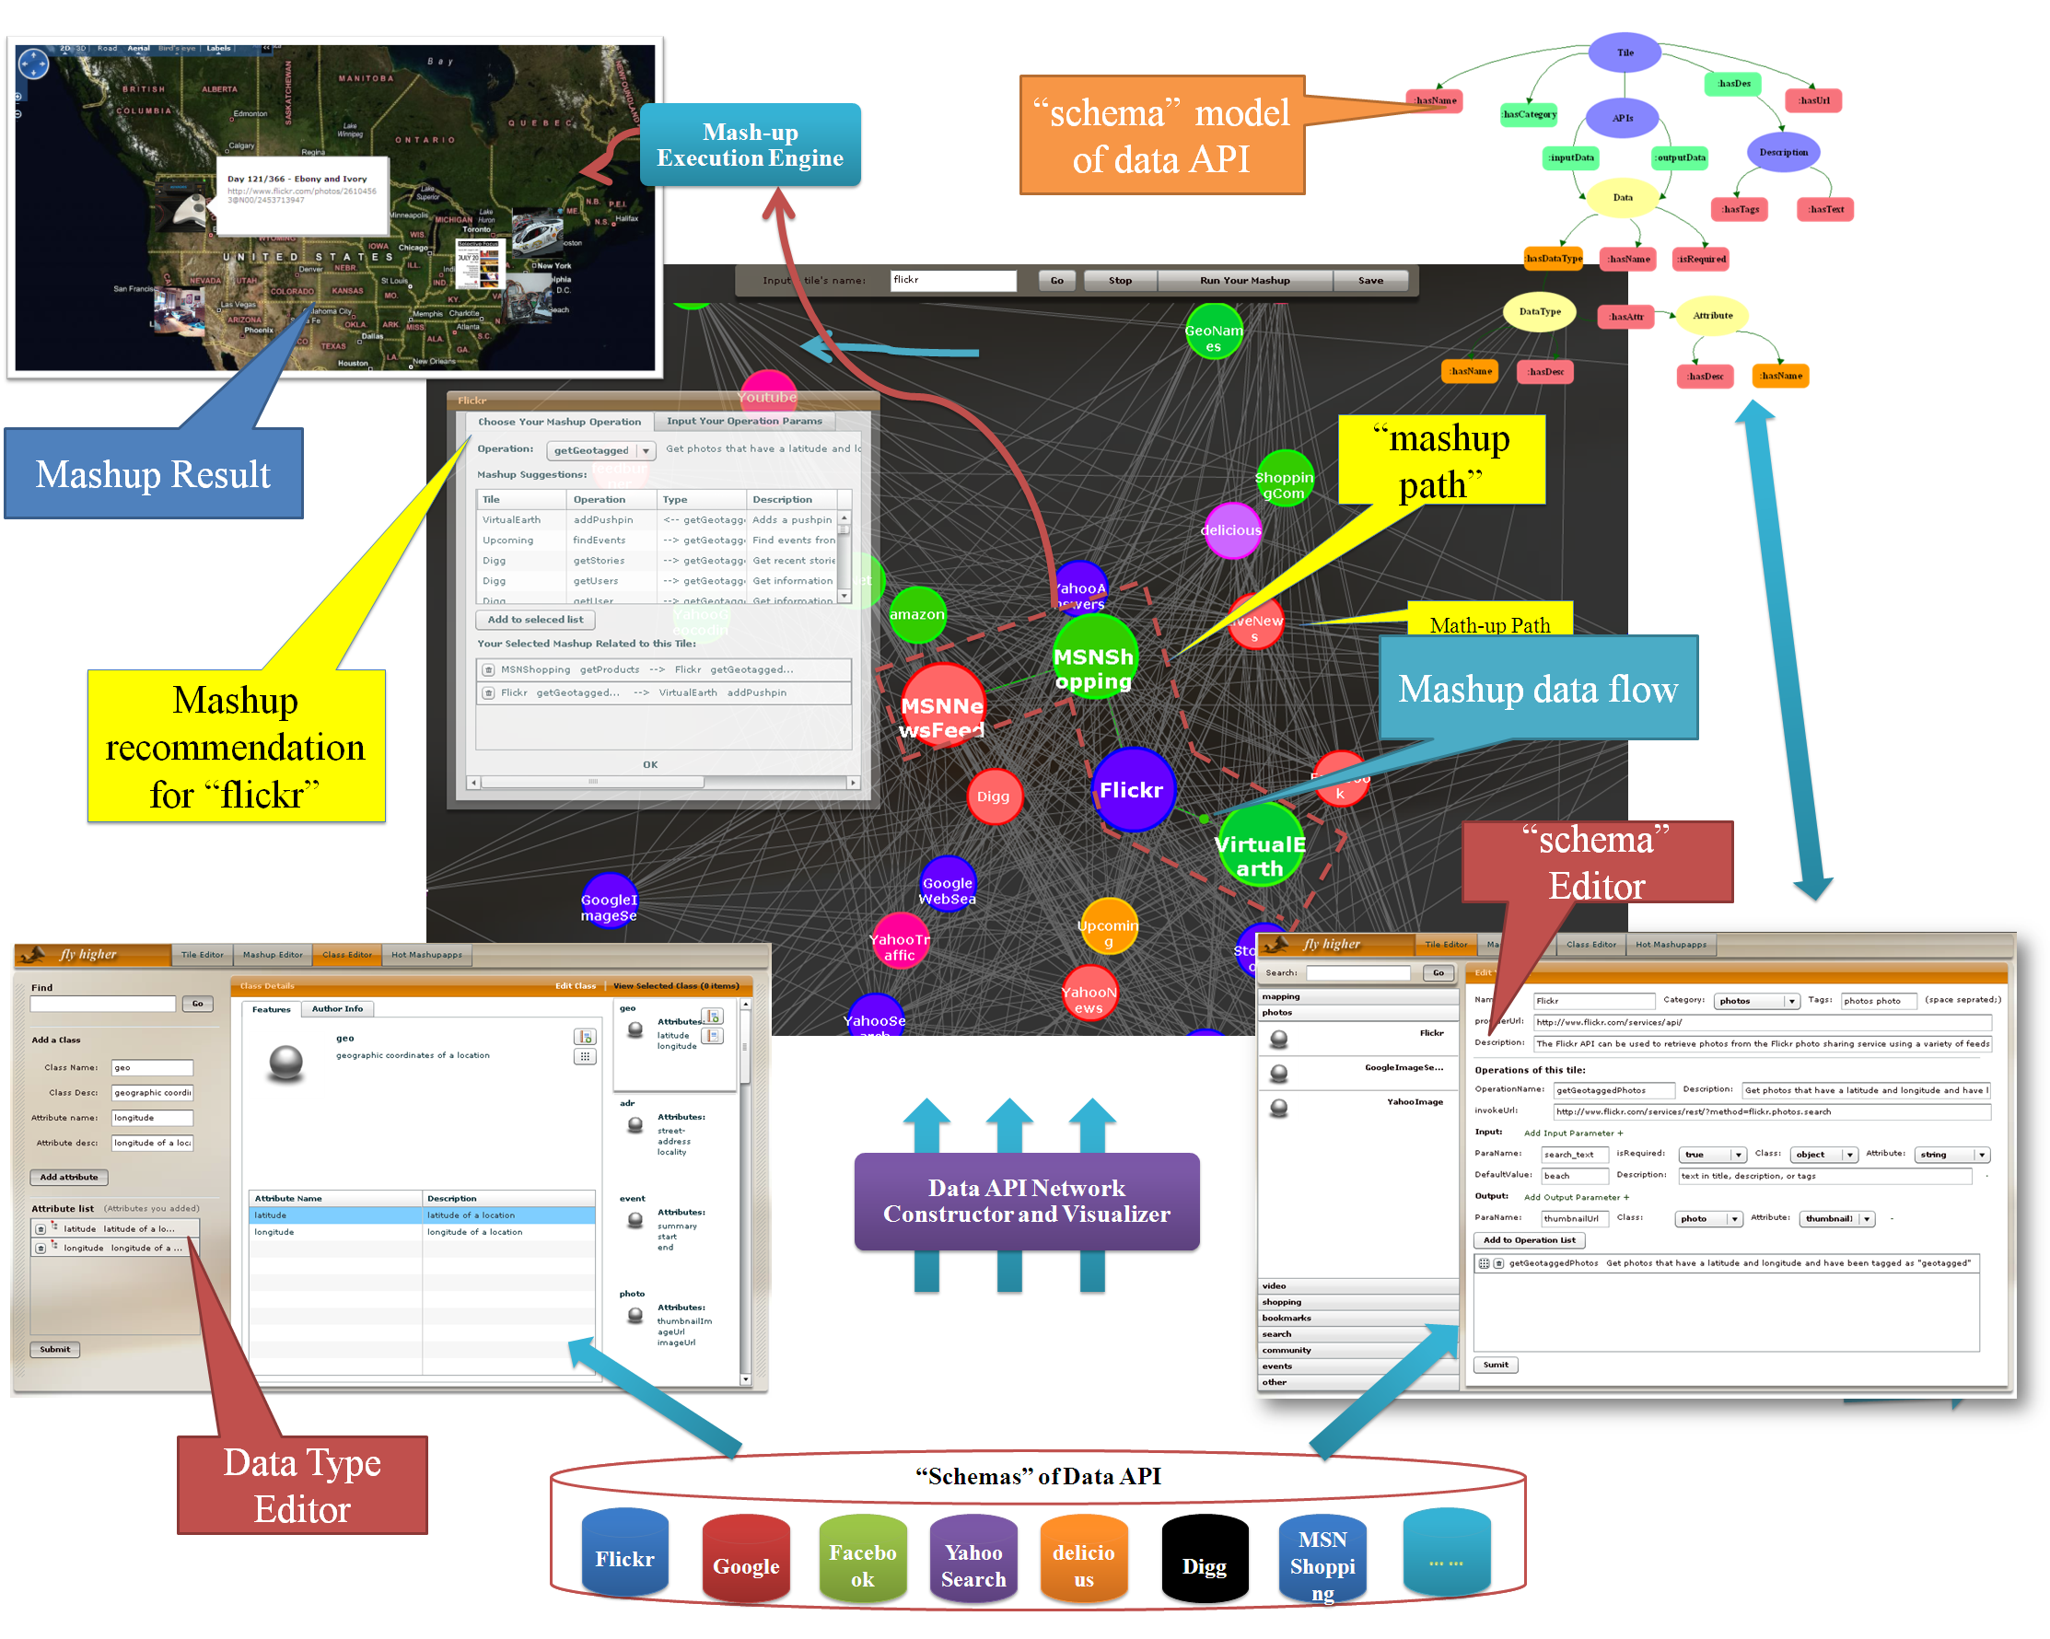
Figure 2: Overview of sMash
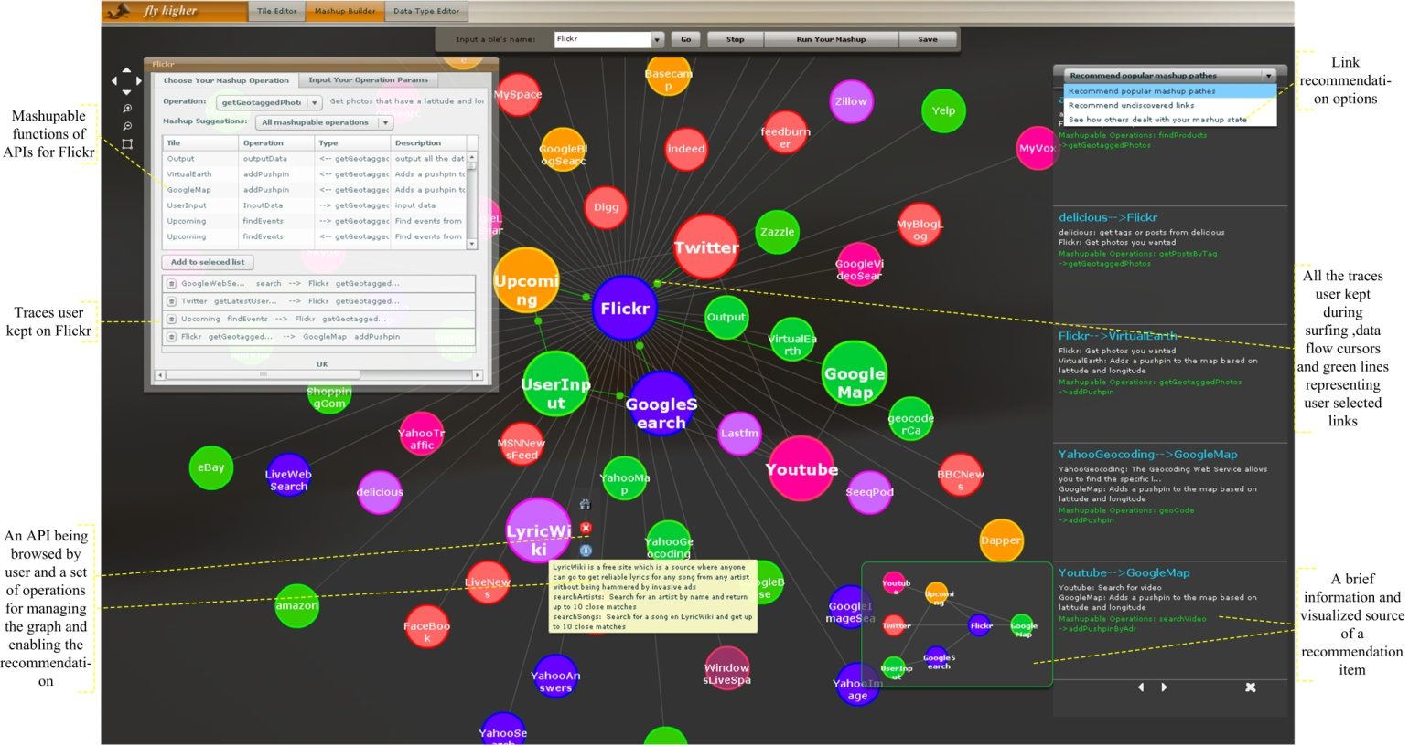Figure 3: A Typical Mashup Scenario
Biz impact/Potential biz opportunity
IBM is offering MashupCenter, which is an enterprise mashup platform to build situational business applications. The technologies developed in this project are directly relevant to that IBM product. Also, many public mashup websites, like Yahoo! Pipe, Microsoft Popfly, will potentially need these technologies.
Social software and semantic technology is gaining wider and wider attention in many modern Web applications. The project tries to advance the social technology in terms of a combination of data mashup and semantic web applications . It has the potential of inspiring and driving new types of mashup and semantic web applications.
Hiring students/faculty as IBM regular/fix term regular employee?
Others

- Further Plan

University contact SIGNATURE: __________ IBM Contact SIGNATURE: __________

DATE: ______________ DATE: ______________

------------------------------------To be filled by IBM internal -------------------------------------------

- 1st line manager Name_________ Signature____________ Date________

Comments：

- 2nd line manager Name_________ Signature____________ Date________

Comments：

- Review Board Name_________ Signature____________ Date________

Comment: （Recommend to continue or not?）

